1. JL Shark - Development  
   Director of vibes and resident visionary. Here to shake up the metaverse!

1. KJ Shark - Development   
   The one who always has your back. Practical, grounded, and with the biggest heart

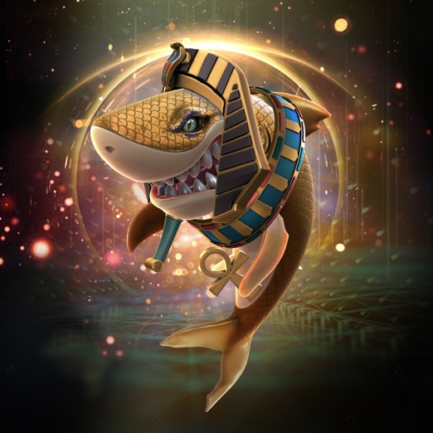

1. DY Shark - Development  
   The glue that holds everyone together. Will fight KJ for the spot of biggest heart

1. LH Shark - Marketing Lead  
   The hype man for all things Metanomics

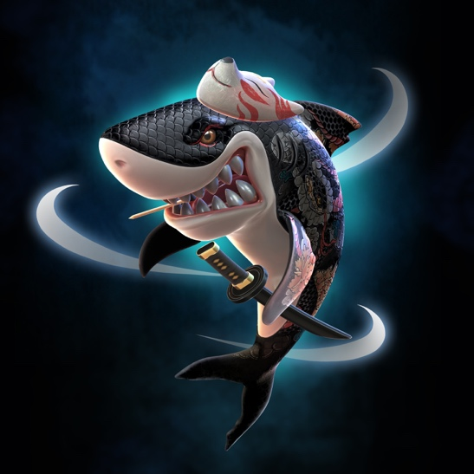

1. NL Shark - Lead Content Editor   
   Oversees all content with her discerning eyes

1. MT Shark - Art Design Lead  
   Fashionably late, but always looking fly

1. MJ Shark - Social Media Lead  
   Here to make sure we are always showing our best side to the world!



1. JB Shark - Lead Content Creator  
   Artistic and talented across different mediums. She’s always reppin’ hard!

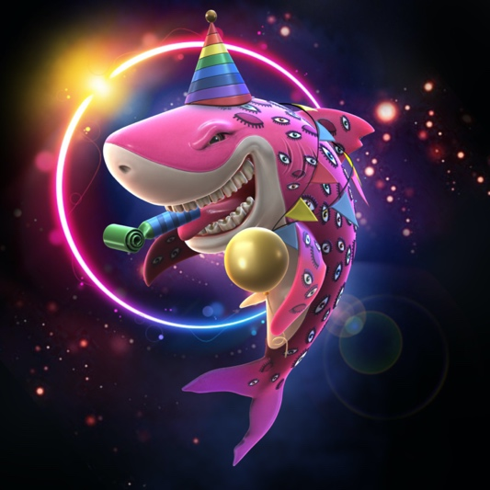

1. MS Shark - Metaverse Tech Lead  
   In charge of the fun! First to show up at the party, and last to leave… mostly because the lights won’t stay on without him

1. AY Shark - Web3 Development  
   Runs on coffee. Rarely touches grass. Might hiss at the sun.



1. TS Shark - Web 3 Development  
   Just call me the exterminator. Here to make sure all our backend tech is bug free

1. SW Shark - Web3 Development

Do not disturb. Busy coding.

